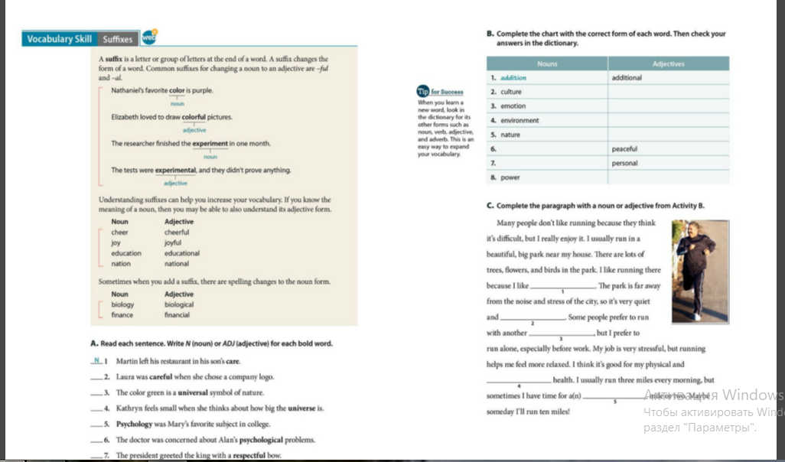
Task 5 Week 9 Do exercise C.

